EDITORIAL LETTER

What is letter to editor?
A letter to the editor is a formal letter sent to a newspaper/magazine editor to highlight social, political, or economic issues. It offers feedback, criticism, or additional information on a problem or issue.

The format of a letter to editor of a Newspaper is as follows –
1. Sender’s address: The address and contact details of the sender are written here. Include an email and phone number, if required or if mentioned in the question.
2. Date: The date is written below the sender’s address after Leaving one space or line.
3. Receiving Editor’s address: The address of the recipient of the mail i.e. the editor is written here.
4. Subject of the letter: The main purpose of the letterforms the subject. It must be written in one line. It must convey the matter for which the letter is written.
5. Salutation (Sir / Respected sir / Madam)
6. Body: The matter of the letter is written here. It is divided into 3 paragraphs as follows –
Paragraph 1: Introduce yourself and the purpose of writing the letter in brief.
Paragraph 2: Give detail of the matter.
Paragraph 3: Conclude by mentioning what you expect from the editor. (For example, you may want him to highlight the issue in his newspaper/magazine).
7. Complimentary Closing
8. Sender’s name, signature, and designation (if any)

Follow these tips to write an effective letter

Make sure your grammar is correct and your writing is error-free. When writing to an editor, paying attention to your language and words becomes extremely important.
Do not use informal language when writing the letter. Use formal language only.
Pay attention to the punctuation, and the format of the letter
Make sure you add the subject properly. Only add what is there in your letter.
Re-read your letter after writing it. Proofreading it will help you spot some errors, if there are, and put a good impression on the editor.

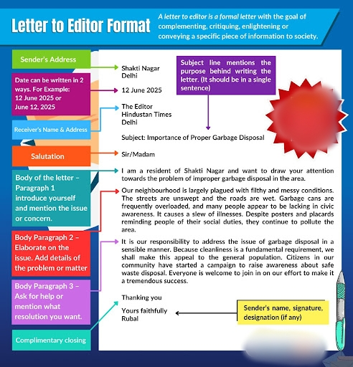

Sample letters.

Sample Letter to the Editor to Highlight the Effects of Air Pollution
56 C, Uppal
East Hyderabad
Hyderabad – 500095
3 January 2022

The Editor
The Indian Express
Secunderabad
Hyderabad – 500003

Subject: Increase of air pollution in East Hyderabad

Respected Sir/Ma’am,
I am Drishya, a member of NGO Prada. I am writing to you to bring to your notice the increasing effect of air pollution in our neighbourhood and in the surrounding areas.
East Hyderabad has seen a rapid increase in the use of private transportation and the number of industrial sectors that have come up in recent years. This has increased the risks of serious health hazards, including breathing difficulties, chronic diseases, lung damage, nausea, fatigue, etc. The hospitals around the area have already seen an unexpected rise in the number of patients showing symptoms of chronic illness, and it is important that people and government authorities are made aware of this dangerous situation at the earliest.
Owing to the seriousness of this situation, I request you to kindly highlight the issue so that some action can be taken to curb the effect of air pollution and decrease the risk of people being affected by it.
Thanking you
Yours sincerely,
Signature
DRISHYA RAGUNATH
Member of NGO Prada

Letter to the Editor Example for Students on Conduction of Offline Examinations amidst the Increasing COVID Rates

23/89, Derby Lane
N G G O Colony
Haryana – 121002
10 January 2022

The Editor
The Indian Express
Gurgaon
Haryana – 121065

Subject: Conduction of offline examinations amidst the increasing COVID rates

Respected Sir/Ma’am,
I am Dhivya Dharshini, a member of the Parent-Teacher Association. I am writing in order to emphasize the decision to conduct offline examinations in schools and colleges when there is a huge increase in the number of COVID cases.
It is a matter of great concern that the disease is spreading sooner than ever in the past two years of the pandemic, and it is not safe for us to let our children travel to their respective schools and colleges to take up examinations in this situation. We have tried to discuss the issue with the authorities of the academic institutions, but no action or decision has been taken so far. It is the need of the hour to take utmost care and abstain from making any sort of physical contact with anyone in order to keep ourselves safe and healthy.
I request you to kindly understand the seriousness of this issue and highlight it in your newspaper so that the academic institutions consider conducting online examinations so that everyone stays safe.
Thanking you
Yours sincerely,
Signature
DHIVYA DHARSHINI
Member of the Parent-Teacher Association

